Have you ever seen a movie whose soundtrack you really loved, where each song perfectly complemented each scene? Or looked at a view and been able to perfectly hear a song in your head? Some songs and images just go well together. I wanted to see if I could use AI to identify the dynamics of this phenomenon and automatically select the right song for a given image.

First things first, data
I needed a dataset of images labeled with songs. Fortunately, I found a dataset here, created by Oramas et al. It’s a collection of album cover images for some of the songs from the Million Song Dataset.

My initial plan was to use transfer learning. This involves taking a Machine Learning algorithm that has been trained for one task and applying it for another. For example, suppose we want to train a model to recognise trucks. We can take a separate neural network that recognises cars and adapt it so it recognises trucks. Transfer learning is particularly helpful when we don’t have a large number of images to train a model from scratch. In my case, transfer learning involves taking a Convolutional Neural Network that has been trained to classify an image in terms of the objects it contains (dogs, houses etc.) and retraining the last layer to classify the image in terms of genre. I tried a few different CNNs including ResNet, AlexNet and VGG. None of them gave an accuracy of higher than 32%. So not great.

Some error analysis revealed a few reasons for the poor performance.

First, album covers are quite similar across genre. A picture of the artist or artists, maybe staring into the distance or holding an instrument. Or a picture of nature.
Figure 1: A Blues image
Figure 2: A Country Image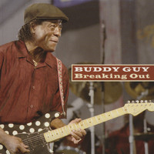
Figure 3: An Electronic Image
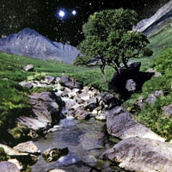Figure 4: A Rock image

Second, CNNs don’t handle image style. Some genres have a very distinctive style that distinguishes their artwork.

Figure 5: A Punk image
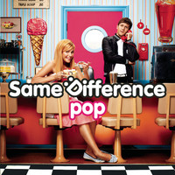Figure 6: A Pop image
Figure 7: A Metal image

Third, the CNNs had issues identifying the content of the images. I ran some of the pre-trained CNNs over the album covers to see if they could identify the content in the images. They didn’t do so well. Below are some images with the classifications generated by the resnet18 algorithm from pytorch.


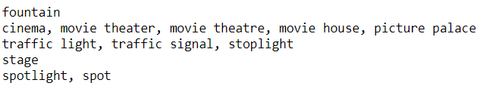

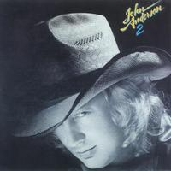

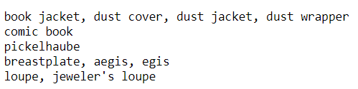



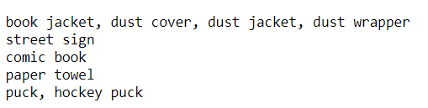

I needed an approach that would handle the content better while also accounting for style.

Enter style transfer
Style transfer is a method that takes a content image and a style image and renders the former in the style of the latter. An example is below:

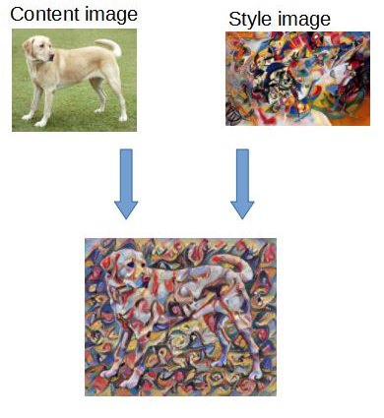

In style transfer, we first create a target image as a random combination of pixels. We then proceed in rounds, computing content distance to the content image and style distance to the style image. These distances are used to update the target image. We stop after the content and style distances reach a certain threshold. This method works well because of robust methods for calculating content and style. So I figured I could repurpose these distances to address my problem. For any image I wanted to match with a song, I could match it with the album cover that minimised the content and style distances.

Now I needed a tutorial on style transfer. After some searching I came across this one by Alexis Jacq.

Then I needed to figure out how to apply the style transfer algorithm to the album image dataset. In Alexis’s tutorial content and style distances are calculated using activation matrices obtained by passing images through the vgg19 CNN from pytorch. To calculate content distance, we pass the content image through the CNN to get an activation from one layer. We then pass the target image (which starts as a random collection of pixels) through the CNN and obtain the activation from the same layer. We then compute the distance between the two activations. Calculating style distance works in a similar manner except we use activations from different layers. I wanted to rework this process to calculate content and style distances between an input image and the album images.

However, I ran into a problem. I couldn’t possibly compute the content and style distances between a target image and each album image one at a time. This would take an extremely long time.

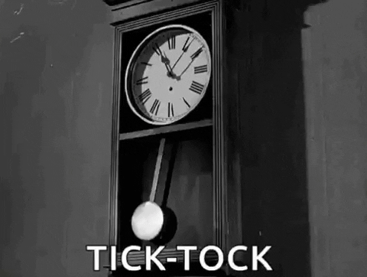

So I needed to figure out how to represent all the training images as two matrices: one containing the content matrices and one containing the style matrices. Then I could compute content and style distances as two matrix operations. My first problem here was the size of the content and style matrices. The content matrix used by in Alexis’s tutorial is of size (128,112,112). There are 5 style matrices: 2 of size (64, 64), 2 of size (128, 128) and 1 of size (256, 256). These matrices were clearly in need of dimensionality reduction if they were to be combined.

Using Principal Components Analysis (PCA) I reduced each style matrix to have 15 columns. I then unrolled each of these matrices and stacked them horizontally to create a single style vector with 9600 elements. PCA expects a 2d matrix, so I first reshaped the content matrices to be of shape (128, 12544) and then used PCA to reduce them to be of shape (128, 50). The content matrices were then unrolled to be vectors with 6400 elements. Diagrams of this process can be seen below.

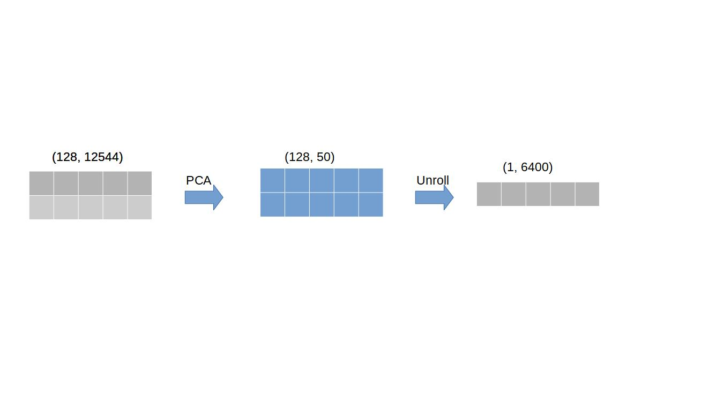Figure 1: Processing a single content matrix

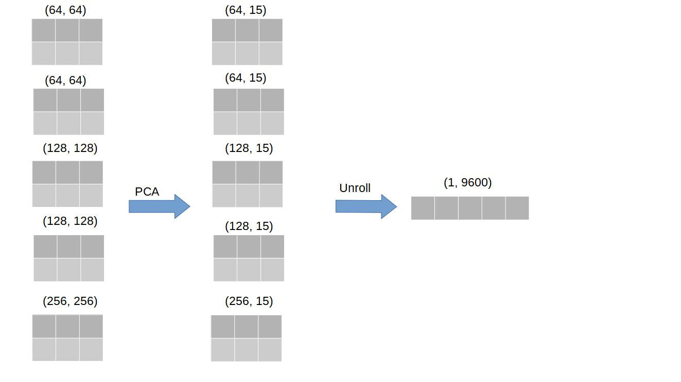Figure 2: Processing a single style image

We’re finally ready to predict. To match a target image to one of the images in the album image dataset we:
1. Combine the unrolled and stacked style matrices for the album images into a single matrix where every row represents one image.
2. Combine the unrolled content matrices for the album images into a single matrix where every row represents one image.
3. Create style and content vectors for the target image.
4. Compute style and content distances between the target image and the album images. Alexis’s tutorial uses Mean Squared Error. Even with the dimensionality reduction this proved unworkable time-wise so I used Euclidean distance instead.
5. Select the image from the Oramas dataset that minimises the content and style distances

But computer vision algorithms are notorious for bias
I needed a way to check that my approach wasn’t encoding any harmful patterns. Thankfully two researchers, Kimmo Karkkainen and Jungseock Joo, have created a dataset of faces. It consists of seven ethnicities: White, Black, Indian, East Asian, Southeast Asian, Middle Eastern, and Latino. The dataset is designed so that no ethnicity is over- or under-represented. To test for bias I applied the following process:
1. For each image in Karkkainen and Joo’s dataset, obtain the closest 10 images in the album image dataset.
2. For each ethnicity, get counts for the album images that were matched in step 1.
3. For each ethnicity, get the images representing top 80% of matches, using the counts from step 2.
4. Get the intersection of top images for each ethnicity
5. For each ethnicity, get the top images that don’t appear in the intersection obtained from step 4. Use these images to create list of images that appear in the top list of at least one ethnicity but not all ethnicities.
6. For each element in the list from step 5, count the number of ethnicities where the element appears in the list of top matches.
7. Using the counts from step 6, obtain the images that appear in the top matches for 2 or more ethnicities and count the different ethnicity combinations that occur.
8. Scan these combinations to determine whether any appear disproportionately.

There did not appear to be any combinations that appeared disproportionately. The joint-highest occurring combination appeared 5 times and contained 6 ethnicities. After applying this process I was left with 22 images that are matched with one ethnicity and no others e.g. an image that only matched with White faces, an image that only matched East Asian faces etc. Examining these images revealed no particular pattern. So based on this bias testing approach there doesn’t seem to be bias present. But I am of course open to other approaches.

It’s finally time to test the approach! This link lists 7 different kinds of photography: Portraits, Photojournalism, Fashion, Sports, Still Life, Editorial, and Architectural. I downloaded images for each of these categories and ran them through the process to get the 10 most similar album images. The results were... interesting.

Across most of the categories, there were multiple examples where it was clear why matches were made e.g. backgrounds, image styles etc.



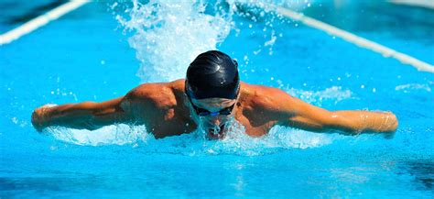
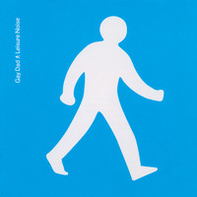




There were also some examples where images appeared to match on content, even though the styles were quite different.

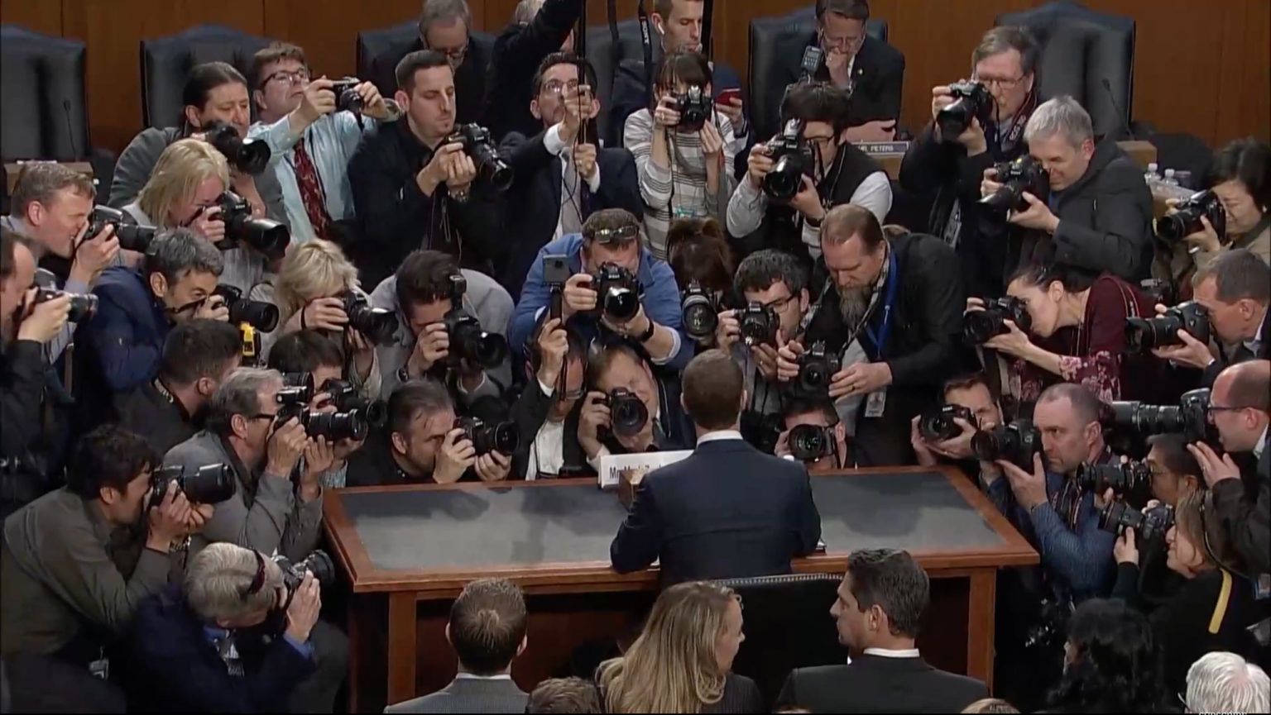

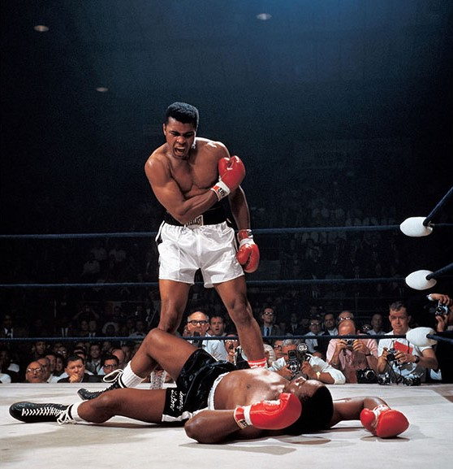



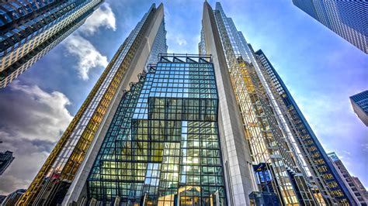

There were also multiple examples where it was unclear why matches were made.

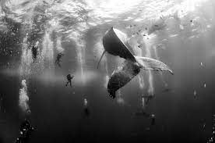
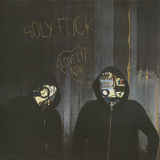

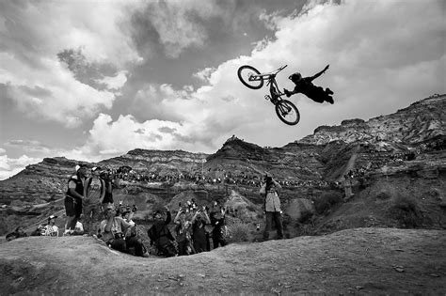





And that’s that! If you have any questions or comments about this work please feel free to contact me.

WARNING: Some of the images in the album image dataset contain adult content such as nudity.

Licenses for the Wikipedia images used to test the approach:
Beilschmiedia miersii - GNU Free Documentation License
Chilkat Inlet - GNU Free Documentation License
Forsten’s Tortoise – Public Domain
Francisco Uranga – Public Domain
John Betsch - Creative Commons Attribution 2.0 Generic
Kermode bear - GNU Free Documentation License
Montesquieu-des-Alberes - GNU Free Documentation License
Mors Kochanski - Creative Commons Attribution-Share Alike 3.0 Unported
The Fox Hunt painting – Public Domain
Xiluo - Creative Commons Attribution-Share Alike 3.0 Unported

References
Oramas, S., Barbieri, F., Nieto, O., and Serra, X (2018). Multimodal Deep Learning for Music Genre Classification, Transactions of the International Society for Music Information Retrieval, V(1).

Karkkainen, K., & Joo, J. (2021). FairFace: Face Attribute Dataset for Balanced Race, Gender, and Age for Bias Measurement and Mitigation. In Proceedings of the IEEE/CVF Winter Conference on Applications of Computer Vision (pp. 1548-1558).

The amount of explained variance for every content and style matrix was at least 95%, which is the generally recommended minimum.

